**User Manual**

**Rando Chat Web App**

Developers:

Fritz Ashley Ereneta

Kenneth Famarin

Mark Jabel Frias

Jared Ibanez

Lee Donghee

Jane Quitoriano

Abstract

Rando Chat app was developed because the developers saw a need for a more privacy-centric chat experience with people across the world. This web application enables its users to freely communicate with strangers online who share their interests without the need to expose any of their sensitive information to other users of the platform. To further improve on the developer’s ideals of security and privacy, possible future releases of this application might include features like reporting a conversation or a user, blocking access to photo sending unless the user on the other end agrees to enable it, and end-to-end encryption. The development team is committed to create more unique and meaningful experiences for users and they hope to deliver these experiences through this web app.

**How to?**

**Register**

To register, simply go to the website and you will be given an option to either login or register. Select the **Register** button.

You will be taken to the signup screen to fill up the form. After completing all fields, scroll down and select the **Register** button and confirm once a dialog box appears. Once the registration is successful, the app will alert you and redirect you to login.

**Main Navigation**

Once you are logged in, a list of rooms you belong to will appear. To access other pages, select your target page by clicking them on the bottom navigation bar.

**Find more rooms**

By selecting the **Room Finder** on the bottom navigation bar, you will be able to see more rooms you can join based on you topic preferences (to be discussed later).

**Settings**

By selecting **Settings** on the bottom navigation bar, you will be able to access your account information, manage your topic preferences and logout from your account.

**Manage Topic Preferences**

Selecting the **Manage Topic Preferences** button on the setting page will take you to a page where you can search for topics, add them to your topic preferences, or remove them from the list of your topic preferences. To save your choices, select the **Save Preferences** button at the bottom of the page.

Create New Room or Topic**

To create a new room or topic, go to the **Room Finder** on the bottom navigation bar and select from the quick actions menu.

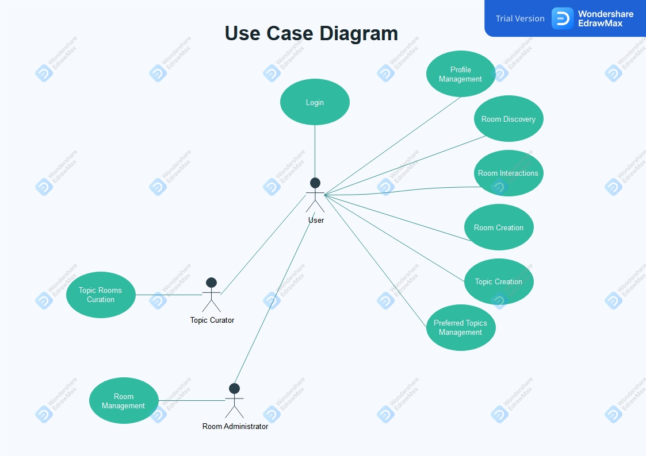**Use Case Diagram**

**Entity Relationship Diagram**

